W3-S2 PRACTICE
MANIPULATE BASIC WIDGETS

 Learning objectives
- Start from an empty Flutter project
- Hot Reload
- Use Flutter doctor, update, create, run
- Use Flutter Documentation

- Manipulate Scaffold, Text, TextStyle, Radius
- Manipulate Colors palettes
- Manipulate Container, BoxDecoration, Center, EdgeInsets, Column
- Create a Custom stateless widget

 No AI tools allowed to solve this practice

How to submit?
- Push your final code on your GitHub repository
- Then attach the GitHub path to the MS Team assignment and turn it in

 Are you lost?
Read the following documentation to be ready for this practice:

https://api.flutter.dev/flutter/material/Scaffold-class.html
https://docs.flutter.dev/ui/widgets/text
https://api.flutter.dev/flutter/widgets/Center-class.html
https://api.flutter.dev/flutter/painting/EdgeInsets-class.html
https://api.flutter.dev/flutter/widgets/Column-class.html
https://api.flutter.dev/flutter/widgets/Container-class.html
https://api.flutter.dev/flutter/painting/BoxDecoration-class.html

BEFORE THIS PRACTICE

Where are you in your Tools skills?
Before the practice we expect you to be able to run the default Flutter Project using an android Device

If you cannot perform it, ask your group teammate to support you before the practice day!

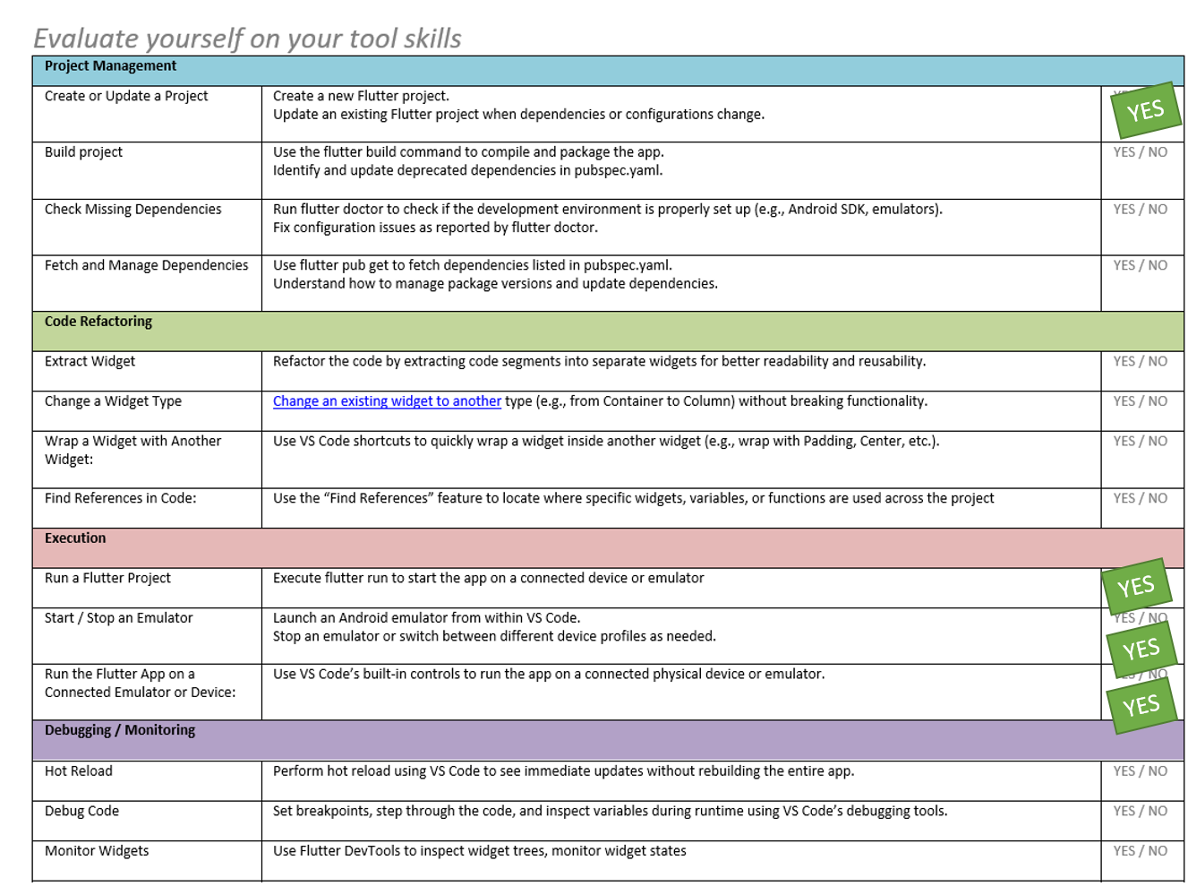

EX 1 – Scaffold, Text
In this exercise, you will be working with the following widgets

- Scaffold: Provides a basic structure for UI, like app bar, drawer, etc.
- Center: Aligns a child widget to the center
- Text: Displays text.

And the following classes
- TextStyle: Styles text appearance.

You need to produce the following mockup and widget structure:
 You are free to customize it!

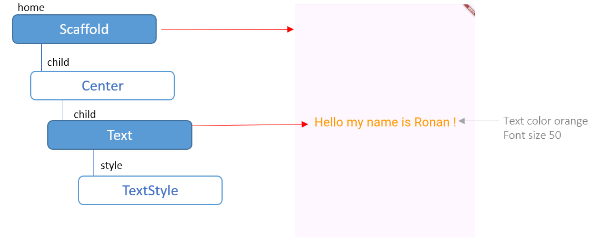

To start
Open W3-S2/EX-1/main.dart

void main() {
runApp(
const MaterialApp( ),
);
}

EX 2 – Container, Insets, BoxDecoration
In this exercise, you will be working with the following widgets
- Container: A customizable box for layout and styling.
- Text: Displays text.
- Center: Aligns a child widget to the center

And the following classes
- EdgeInsets: Sets padding or margin.
- BoxDecoration: Styles a container's background, border, etc.
- BorderRadius: Rounds container corners.
- TextStyle: Styles text appearance.

You need to produce the following mockup and widget structure:
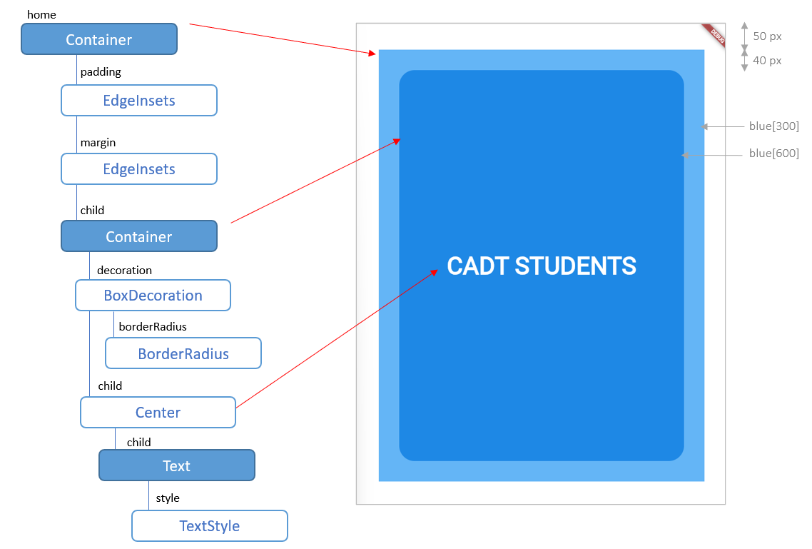

We recommend you to follow the bellow steps to be able to understand each widget in details.
However, you are free to choose your favorite workflow!

To start
Open W3-S2/EX-2/main.dart

void main() {
runApp(MaterialApp(
home: Container( ),
));
}

STEP 1 |  | Just a blue container for the home…  MaterialApp  home: Container
STEP 2 | 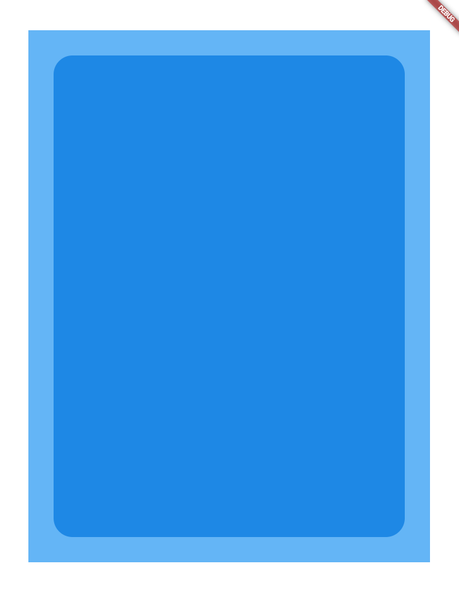 | Add an inner container and some padding margins and box decoration  MaterialApp  home: Container  margin: EdgeInsets  padding: EdgeInsets  child: Container  decoration: BoxDecoration
STEP 3 | 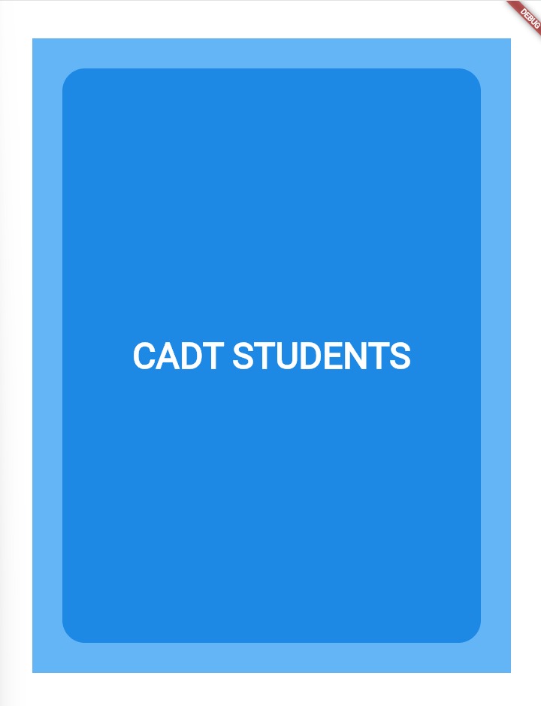 | Add the Text, centered, and style it.  MaterialApp  home: Container  margin: EdgeInsets  padding: EdgeInsets  child: Container  decoration: BoxDecoration  child: Center  child: Text  style TextStyle

 In this exercise, we haven’t used the Scaffold widget: Why? What is the purpose of this widget?

EX 3 – Column Gradient,
In this exercise, you will be working with the following widgets

- Container: A customizable box for layout and styling.
- Column Arranges widgets vertically in a column.

And he following classes
- EdgeInsets: Sets padding or margin.
- BoxDecoration: Styles a container's background, border, etc.

You need to produce the following mockup and widget structure:
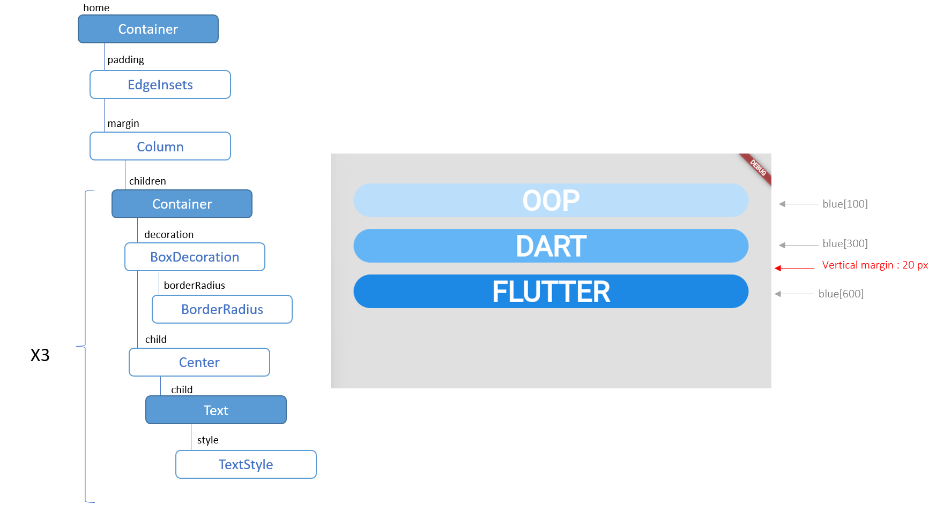

BONUS
In the last item, add a linear gradient as specified bellow

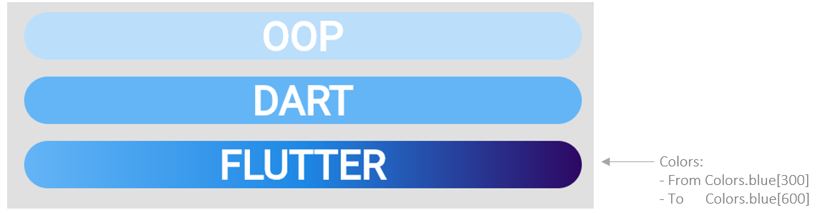

EX 4 – Extract widget to a Stateless Widget
Startin from previous exercise, your You need to extract the repetitive card design into a custom Stateless Widget called CustomCard.
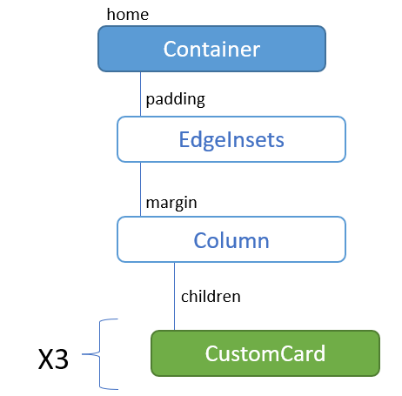

This custom widget will take 2 parameters:
Parameter name | Type | Is optional? | Default value
Text | String | no | No
Color | Color | yes | Blue

As example the previous code will be refactored as follow:
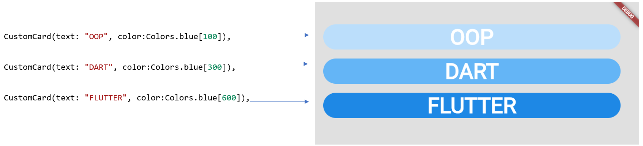

Q1 – Starting from previous exercise, extract the Container into a Stateless widget (CustomCard)
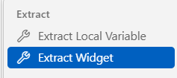
VSCode can help you to extract widget!

Q2– Add widget constructor parameters
Q3 – Update the main() to call this CustomCard widget

BONUS
If you were able to manage linear gradient, add another constructor parameter to display the card with gradient colors.

